Beaminster Museum Extension

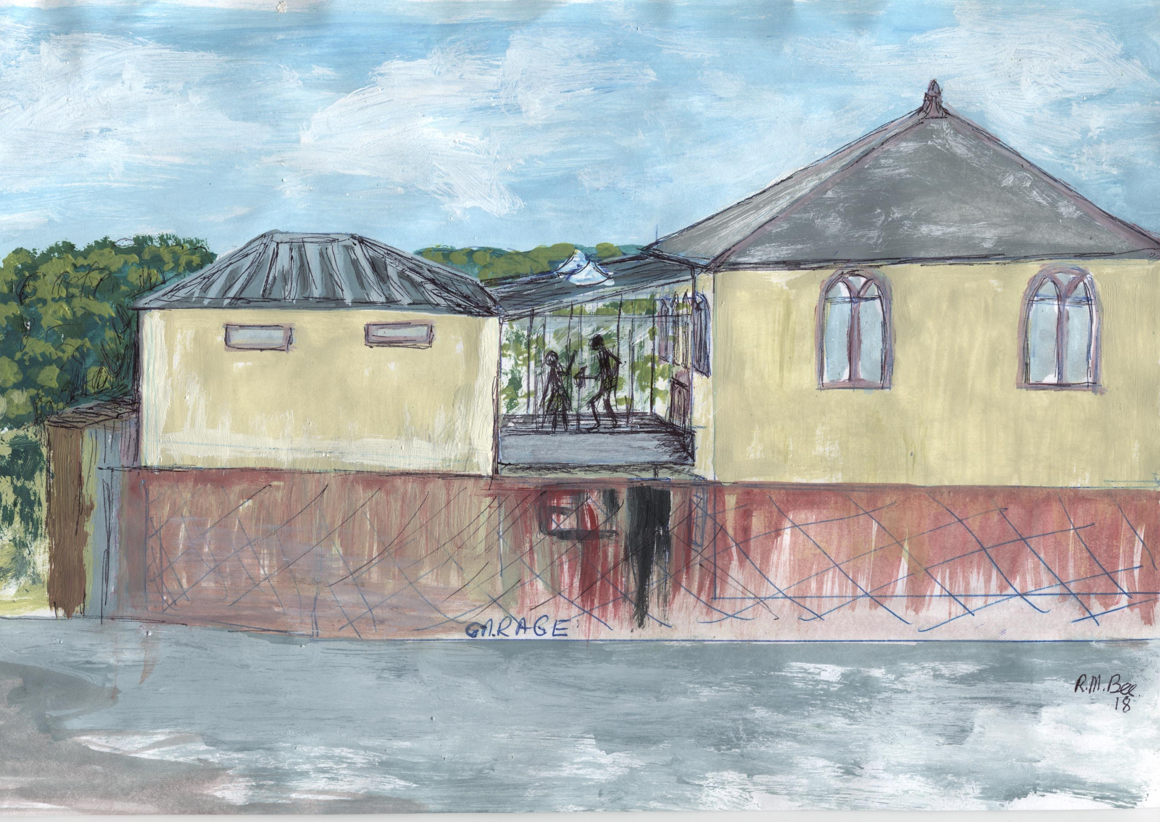
Our extension will enable the Museum to:-

- improve our offering to schools and adult groups
- enhance our facilities for family history and general research
- make it easier to access our photographic and oral history archive
- enable us to display more of our local heritage and in better ways
- provide sufficient storage for our artefacts for years to come
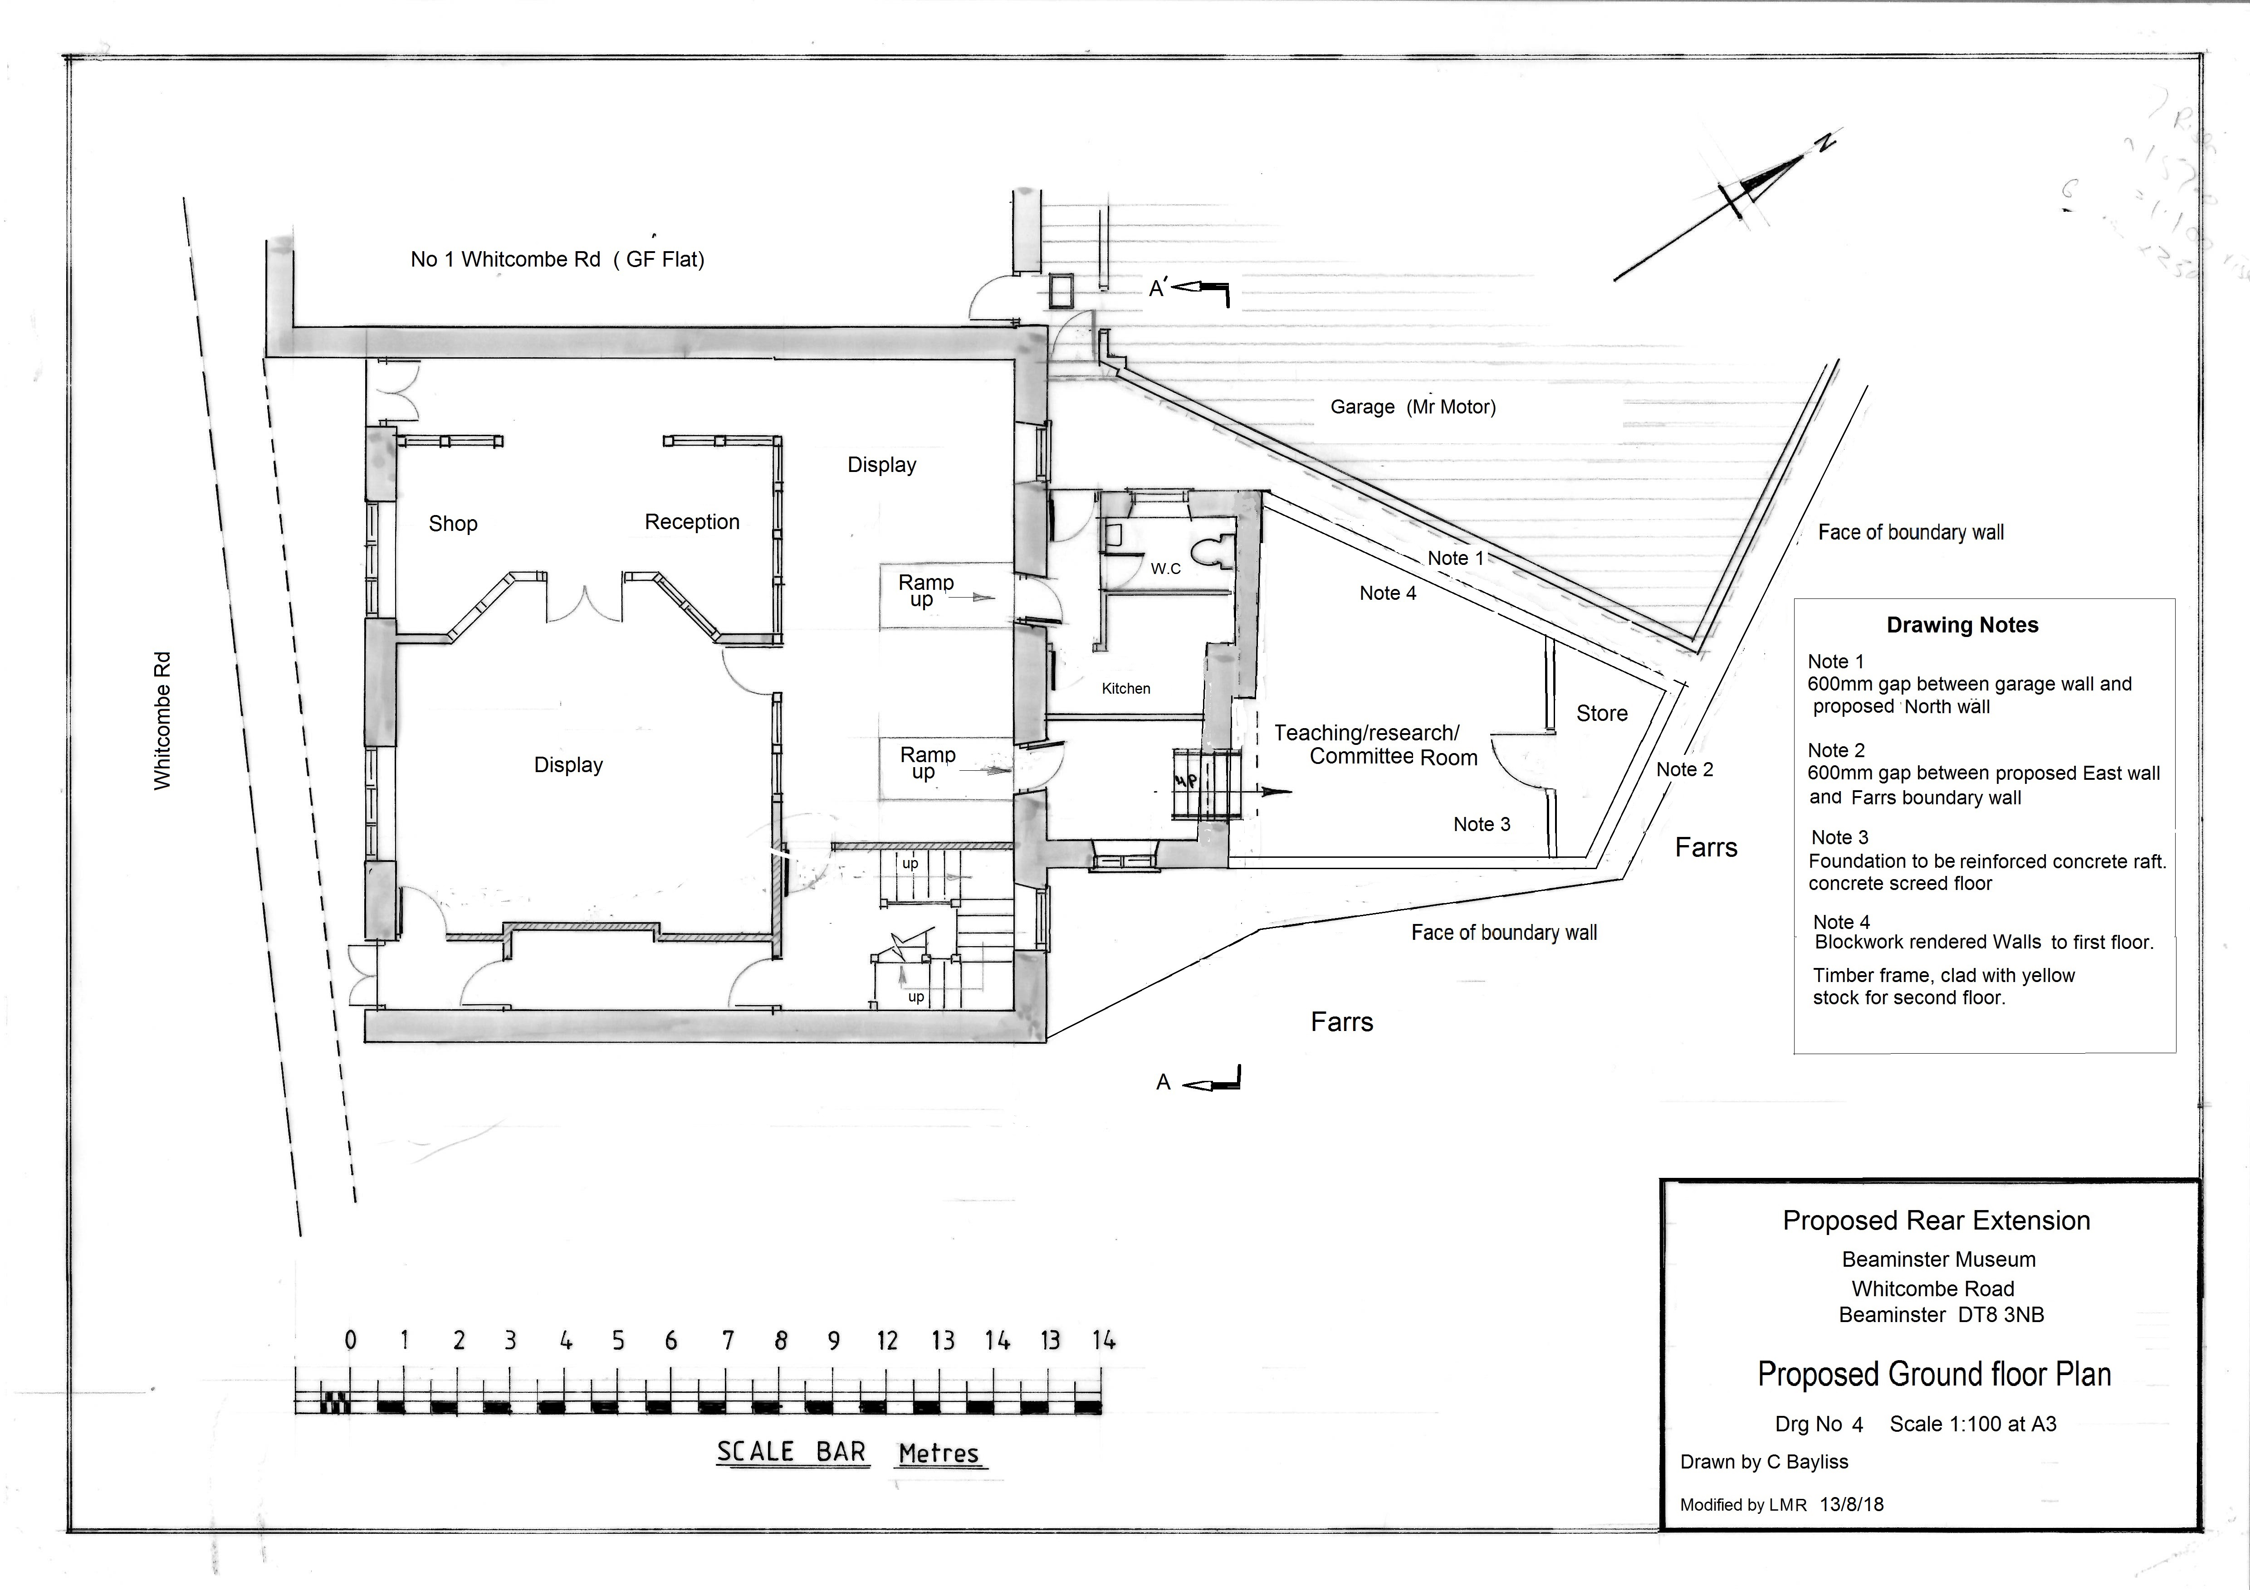
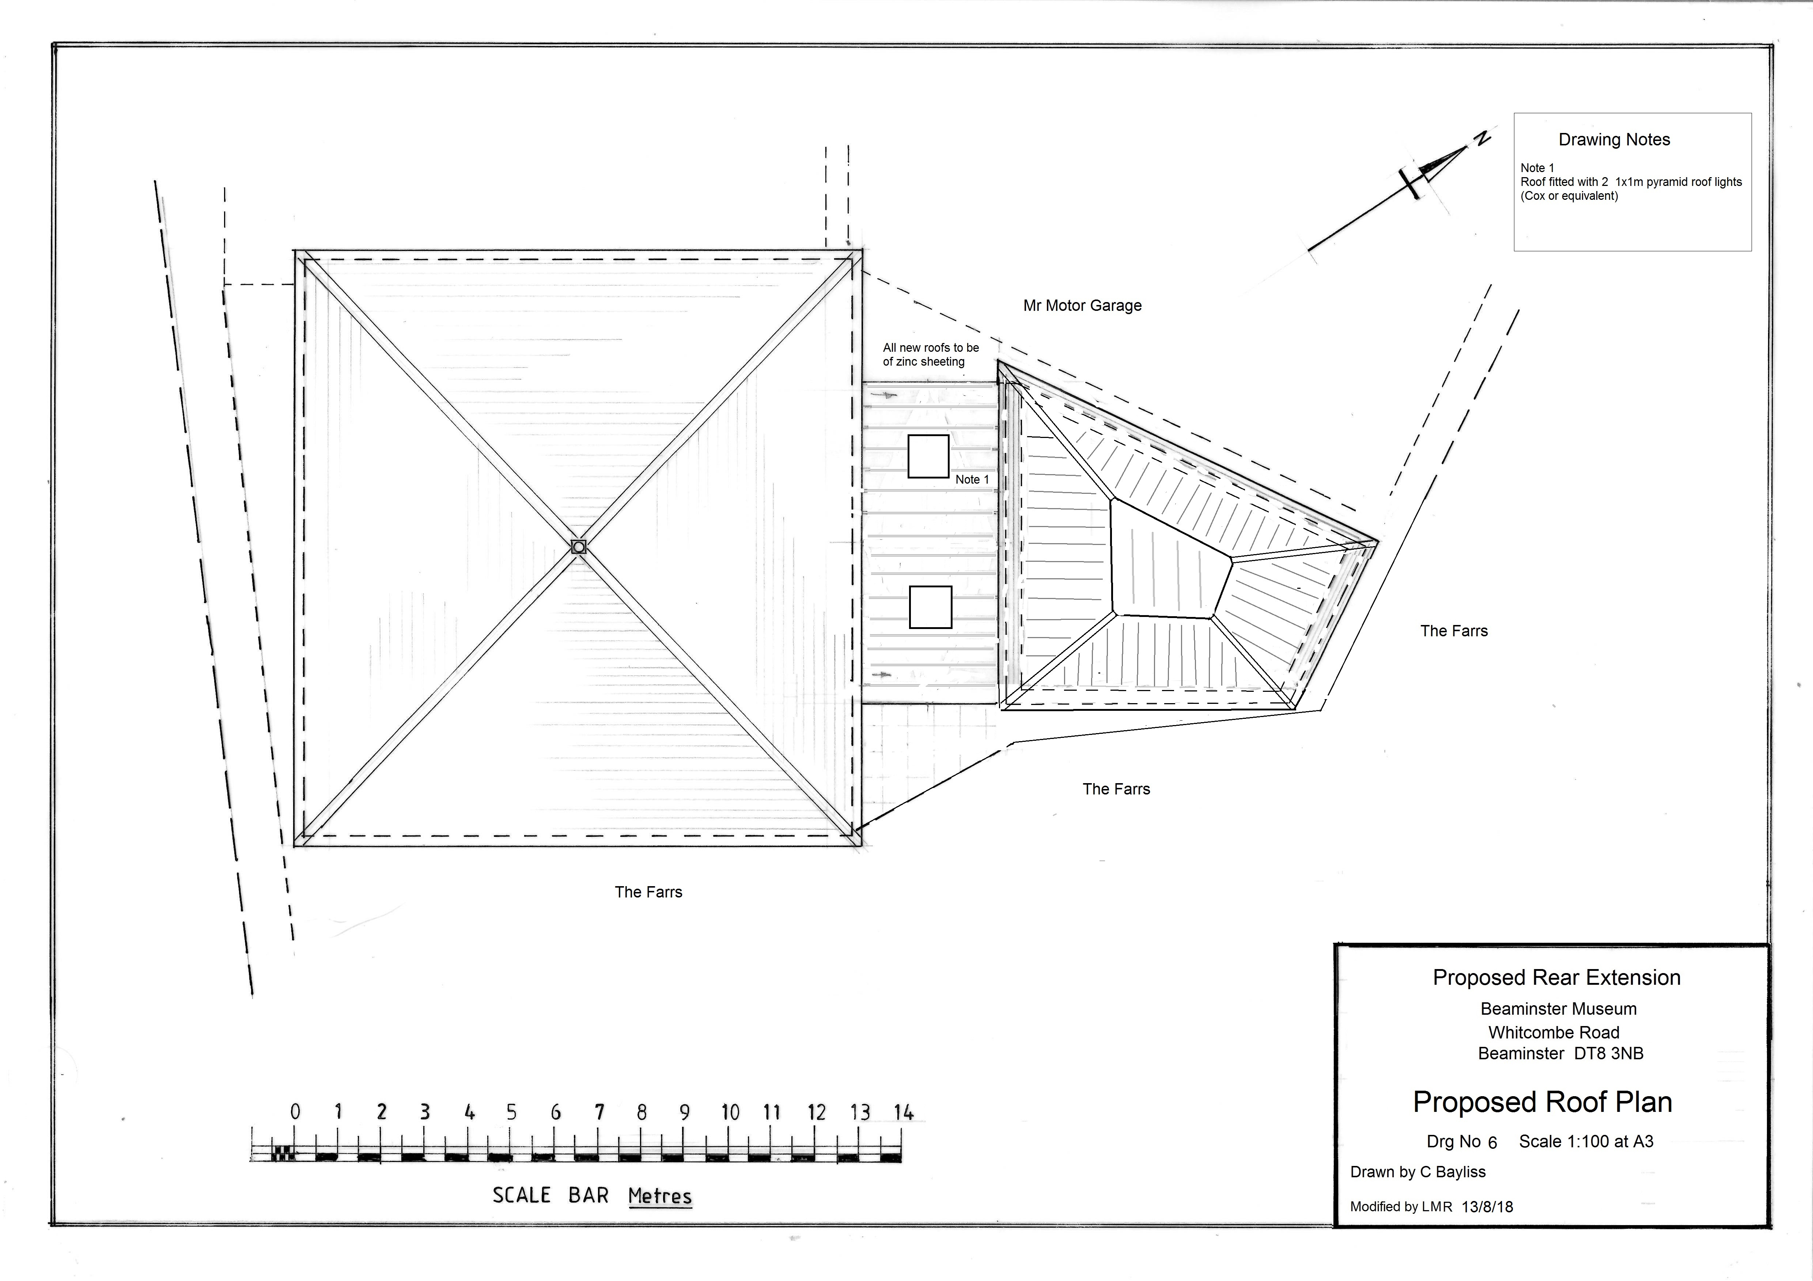
- increase space for community activities such as Beaminster Festival

The plans are approved, we are now looking or financial support.
We already have £60,000 towards our target of £150,000

Please come and join us!

