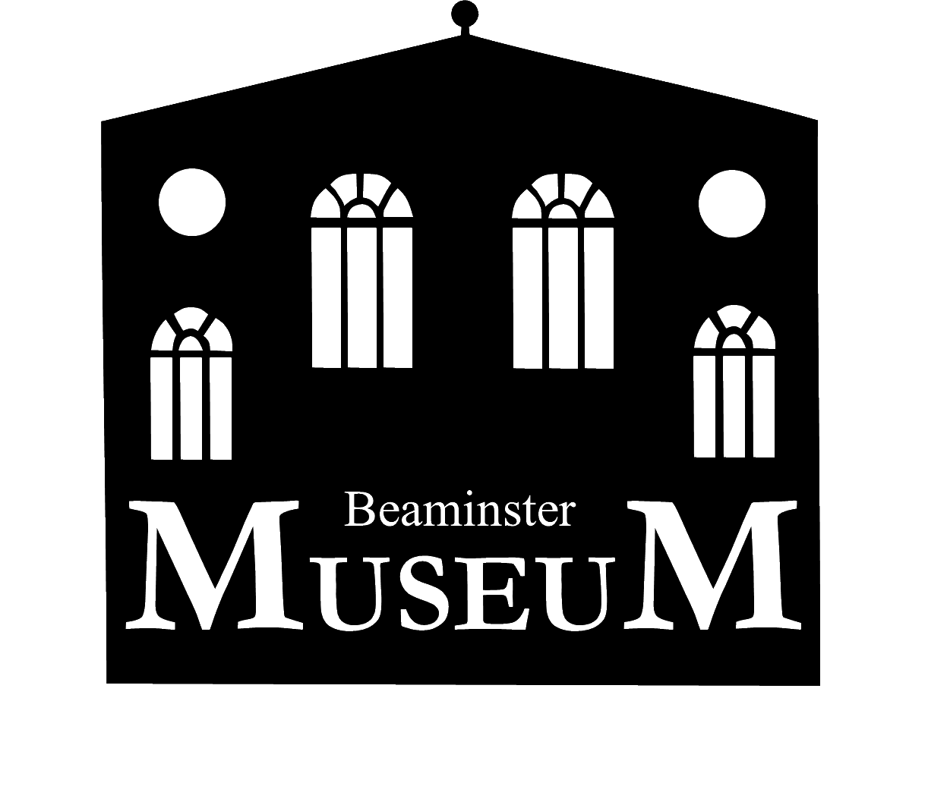
BEAMINSTER MUSEUM TRUST
Minutes of the 34th Annual General Meeting
Held on Tuesday 24th January 2023 in the Museum

The Chairman welcomed everybody and reminded them that, in accordance with the Constitution, as Friends of the Beaminster Museum. they are the electorate of both the Trustees and the Management Committee and their support was essential for the functioning of the Museum charity.

Apologies: Apologies for absence had been received from 11 Friends
Present: 29 Friends were present.
- Minutes of the last meeting: The Minutes of the 34rd Annual General Meeting held on 26th January 2022, having been duly proposed and seconded, were approved.

- Matters arising: It was suggested, and agreed, that for the 2023 season Stewards badges, used by Stewards on duty at the reception desk, should show the Steward’s name. The Chairman will progress.
3. Chairman of the Trustees Report: Murray Rose (MR) reported that the Extension project had been completed on time and within budget in time for the opening of the 2022 season with the Chesterrman Room and Rose Gallery both being well used for new exhibitions and the Chesterman Room also providing valuable space for research and the storage of historical records
MR reminded that the Trustees are responsible for ensuring that the Policies and Forward Plan are kept up to date as these will be required for the regular Accreditation inspection. Work on the updating is proceeding.
MR announced that after 32 years as a Trustee, he was now retiring but said that any suggestions as to anybody interested in becoming a Trustee would be welcomed,
The Chairman thanked MR for his involvement with the Museum right from the first time that the idea for a museum was formulated. He said that Alec Crawford, already a Trustee, had agreed to take over as Chairman of the Trustees on an interim basis pending the appointment of a new Chairman.
4. Treasurer’s Report: Linda le Breton reported that the total of donations from visitors to the museum had exceeded the income that would have been derived from the previous entrance fee and donations also benefited from Gift Aid.
Being on an electricity 3 year fixed tariff with Octopus Energy had considerably benefited the museum but it was not yet known what the new tariff would be from 30th April 2023.
With Trustees having increased the permanent reserve to £10,000, Linda reported that the museum accounts were is a healthy position.
The Accounts having been proposed and seconded, their adoption was approved unanimously.
Colin Schofield, having agreed to stand and having been duly proposed and seconded, was elected as Accounts Examiner.
5. Election of Officers and Management Committee:
The following having agreed to stand and having been duly proposed and seconded, were unanimously elected for a further year:
Chairman: Matthew Kirkman
Hon Treasurer: Linda le Breton
Hon Secretary: Alec Crawford
Members: Bid Wheeler
John Boothby
Richard Smith
6. Any other business:
Ann Hudson proposed that Stewards whilst in the building should wear name tags to enable easy recognition by, amongst others, those suffering from dementia or other similar conditions. This was unanimously agreed.
7. Date of next meeting: Tuesday 23rd January 2024 at 2.00pm in the Museum.

